Differentiated prevention, testing and community ART delivery for key and vulnerable populations, Tanzania

Albert Komba, Jhpiego – led Sauti Project, albert.komba@jhpiego.org

Overview
The Sauti Project, awarded by USAID to Jhpiego (an affiliate of Johns Hopkins University) and partners EngenderHealth, Pact and the National Institute for Medical Research (NIMR) Mwanza, seeks to contribute to the improved health status of all Tanzanians through a sustained reduction in new HIV infections in support of the Government of Tanzania’s (GOT) commitment to HIV prevention. The Sauti project is implementing community-based combination HIV prevention, treatment, positive health, dignity and prevention (PHDP) and family planning (FP) services for key and vulnerable populations (KVP). These include key populations (i.e. female sex workers [FSWs] and men who have sex with men [MSM]), vulnerable populations (i.e. vulnerable out-of-school adolescent girls and young women [vAGYW] aged 15-24 years, and partners of female sex workers [PFSWs]) and other vulnerable populations at increased risk of HIV acquisition and transmission (e.g. mobile men, men and women in transient work places, and high risk children aged 18 months – 14 years).

project goals and interventions
Sauti Project’s goal is to have all KVP in project communities able to actively access a core package of vulnerability-tailored, high-quality, client- and community-centred prevention services, combining biomedical, behavioural and structural interventions. The development and implementation of the interventions is done with the active support and participation of KVP, their partners, families, and health providers, as well as the wider community, community based organizations, GOT agencies, and other key stakeholders. The table below summarizes interventions provided to MSM and FSWs using the building blocks (Table 1).

Table 1: Sauti Project building blocks
 | Social Behaviour Change Communication (SBCC)/Gender | Linkage to Care | Biomedical Package
WHEN | As needed, monthly for support groups | As needed, and following national guidelines | HIV testing services (HTS) – for those who test negative, re-testing should be done after 4 weeks and, thereafter, routine HIV testing should be offered every 6 months  PrEP - monthly
WHERE | Community and homes | Community and homes | At hotspot venues (e.g. brothels, guest houses, etc.) and homes
WHO | Peer Educators | Nurse, Clinicians, Peer Educators | Nurse, Clinicians
WHAT | Peer led behaviour change education (curriculum-based), Demand creation for combination prevention services, HIV self-testing distribution, PLHIV support groups, PrEP support groups | HIV Care & Treatment, gender-based violence care, Intrauterine Device, and Permanent FP methods | Core package: HIV testing (provider initiated), HIV self-testing, Family planning, Syndromic screening of TB, gender based violence, STI and Alcohol/drug use, Syphilis testing,  Expanded package: STI periodic presumptive treatment (PPT), PrEP, Community ART initiation & refills for stable clients (provided in some districts only)

Project implementation
Sauti is in its fourth year of implementation. The project is currently in over 51 districts located in 14 regions in mainland Tanzania. The rollout of the interventions was done phase-wise starting with the core package in five regions and later expanding scope and geography. In order to standardize providers’ and peers’ competencies, the project invested the first year of the program to develop training materials, standard operating procedures and job aides; training providers and peers; developing monitoring tools; building capacity of sub-granted community based organizations (currently we have 18); conducting KP mapping using a geographic information system (GIS); and establishing strong partnerships with local government, community structures, and KPs.

Data
From July 2015 – September 2017, the project cumulatively provided biomedical services to 226,161KPs (HTS: 209,877, FP: 34,855, STI PPT 34,531), identified 53,410 newly HIV positive KPs and linked 32,597 to care and treatment, and provided SBCC/gender interventions to 86, 603 FSW and 11,334 MSM, and provided Community ART to 297 KPs. (Note: PrEP and HIV self-testing will commence in April 2018).

SUCCESSES and CHALLENGES
As many other KVP-focused programs, since the inception of the project, Sauti was facing a lot of challenges in testing and linking HIV positive KVPs who do not know their status, and successfully link them to care and treatment clinics. For instance, in the fiscal year 2017 (October 2016 – September 2017), the project’s goal was to test 541,682 and diagnose 37,450 individuals. However, by May 2017, the project had only achieved 43% and 23% of its testing and new HIV diagnosis, respectively. In order to address this challenge, in May 2017, the project leadership designed a new strategy named “Diagnose One, Link One” (D1L1). Under this strategy, a) all the HTS providers were allocated testing targets every day, 2) a real-time performance monitoring and guidance using WhatsApp groups was introduced; 3) all hotspots were mapped using GIS; and 4) the effective use of daily data dashboards to guide HTS delivery was intensified. As a result, improvements were observed in both HIV positivity yield and enrolment. This trend was similar to both key and vulnerable populations. Figure 1 and 2 below illustrates the observed improvements.

Figure 1. Increased Yield and Number of Newly Diagnosed PLHIV following Introduction of Diagnose One, Link One (October 2016 to September 2017)
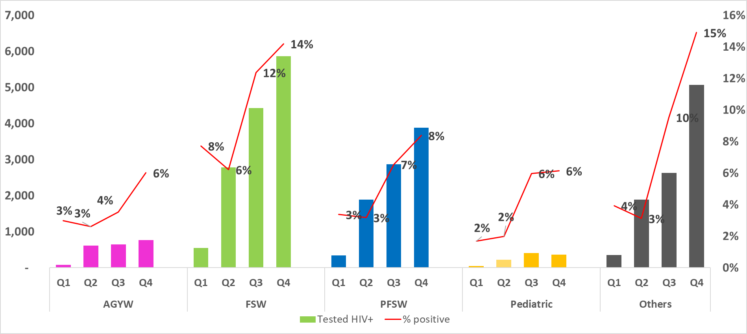

Figure 2. Increased Enrolment in Care and Treatment following Introduction of Diagnose One, Link One
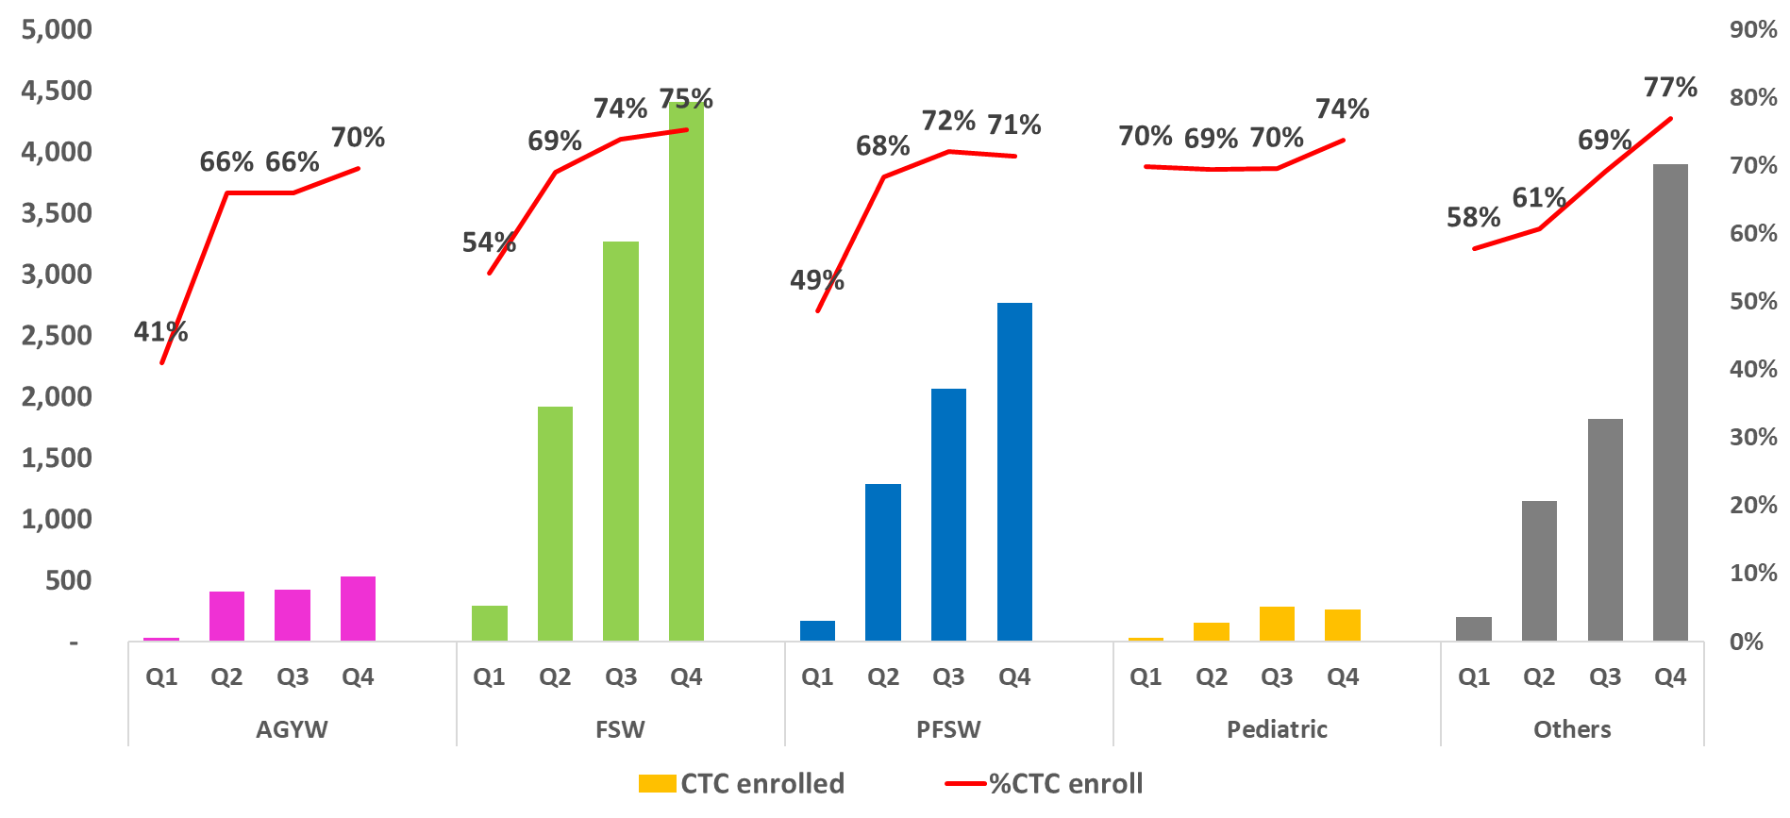
Key:
AGYW: Adolescent Girls and Young Women (15-24 years), FSW: Female Sex Workers, PFSW: Partners of Female Sex Workers

The main implementation challenges include persisting stigma and discrimination and unfriendly services for KPs.

